
AI BASED CROP DISEASE DETECTION SYSTEM
A CAPSTONE PROJECT REPORT
Submitted in the partial fulfilment for the Course of
CSA1711
ARTIFICIAL INTELLIGENCE
to the award of the degree of
BACHELOR OF ENGINEERING
IN
Computer Science and Engineering

Submitted by
S.MYTHILI(192411250)
G.BHAVYA(192411114)
S.ROOBINI(192421114)
Under the Supervision of
Dr. Krishna Kumar Kathiresan

July-September 2026



SIMATS ENGINEERING
Saveetha Institute of Medical and Technical Sciences
Chennai-602105

DECLARATION

We, S.Mythili (192411250),G.Bhavya(192411114),S.Roobini(192421114)of the [CSE], Saveetha Institute of Medical and Technical Sciences, Saveetha University, Chennai, hereby declare that the Capstone Project Work entitled ‘AI BASED CROP DISEASE DETECTION ’ is the result of our own bonafide efforts. To the best of our knowledge, the work presented herein is original, accurate, and has been carried out in accordance with principles of engineering ethics.

Place: Chennai
Date: 07/09/2026

Signature of the Students with Names
S.Mythili
G.Bhavya
S.Roobini



SIMATS ENGINEERING
Saveetha Institute of Medical and Technical Sciences
Chennai-602105

BONAFIDE CERTIFICATE

This is to certify that the Capstone Project entitled “AI BASED CROP DISEASE DETECTION ’” has been carried out by S.Mythili,G.Bhavya,S.Roobini under the supervision of Dr. Krishna Kumar K and is submitted in partial fulfilment of the requirements for the current semester of the B.Tech CSE program at Saveetha Institute of Medical and Technical Sciences, Chennai.

SIGNATURE SIGNATURE
Dr. Rashmitha Khilar Dr. KrishnaKumar K
Department Head Professor
Computer Science Engineering Computer Science Engineering
Saveetha School of Engineering Saveetha School of Engineering
SIMATS SIMATS

Submitted for the Project work Viva-Voce held on __________________________________

INTERNAL EXAMINER EXTERNAL EXAMINER

ACKNOWLEDGEMENT

We would like to express our heartfelt gratitude to all those who supported and guided us throughout the successful completion of our Capstone Project. We are deeply thankful to our respected Founder and Chancellor, Dr. N.M. Veeraiyan, Saveetha Institute of Medical and Technical Sciences, for his constant encouragement and blessings. We also express our sincere thanks to our Pro-Chancellor, Dr. Deepak Nallaswamy Veeraiyan, and our Vice-Chancellor, Dr. S. Suresh Kumar, for their visionary leadership and moral support during the course of this project.
We are truly grateful to our Director, Dr. Ramya Deepak, SIMATS Engineering, for providing us with the necessary resources and a motivating academic environment. Our special thanks to our Principal, Dr. B. Ramesh for granting us access to the institute’s facilities and encouraging us throughout the process. We sincerely thank our Head of the Department, Dr. Rashmitha Khilar for his continuous support, valuable guidance, and constant motivation.
We are especially indebted to our guide, Dr. krishnaKumar K for his creative suggestions, consistent feedback, and unwavering support during each stage of the project. We also express our gratitude to the Project Coordinators, Review Panel Members (Internal and External), and the entire faculty team for their constructive feedback and valuable inputs that helped improve the quality of our work. Finally, we thank all faculty members, lab technicians, our parents, and friends for their continuous encouragement and support.

Signature With Student Name
S.MYTHILI
G.BHAVYA
S.ROOBINI

ABSTRACT

The increasing demand for efficient and sustainable agriculture has driven the development of intelligent systems for early and accurate crop disease detection. Traditional methods of identifying crop diseases mainly depend on manual inspection by farmers or agricultural experts, which can be time-consuming, costly, and prone to human error. Delayed identification of diseases can result in reduced crop yield, poor quality, and significant economic losses. This project presents the development of an “AI-based crop disease detection system” designed to provide fast, accurate, and reliable disease identification using artificial intelligence and image processing techniques.
The proposed system uses a camera or mobile device to capture images of crop leaves. These images are processed and analyzed using an AI-based classification model to identify disease symptoms such as leaf spots, discoloration, lesions, and abnormal patterns. The system compares the extracted features with trained disease patterns and predicts the type of disease affecting the crop. Based on the prediction, the system can provide information about the detected disease and suitable preventive or treatment recommendations. This helps farmers take timely action and reduce crop damage.
To improve reliability, the system is designed to handle different crop types, lighting conditions, and disease symptoms. A user-friendly interface can be provided through a web or mobile application, allowing farmers to upload leaf images and receive results quickly. The system can also be extended with IoT sensors and cloud technologies to monitor crop conditions continuously, including environmental factors such as temperature and humidity.
Experimental evaluation of the proposed system demonstrates its ability to detect common crop diseases with high accuracy and reduced detection time. The system minimizes the dependence on manual inspection and provides an accessible solution for farmers, especially in areas where agricultural experts may not be readily available. The proposed AI-based crop disease detection system contributes to smart agriculture by enabling early disease identification, reducing crop losses, improving productivity, and supporting efficient and sustainable farming practices.

TABLE OF CONTENTS
S.NO. | CONTENT | PAGENO.
 | ABSTRACT | 5
 | ACKNOWLEDGMENT | 4
1. | INTRODUCTION | 8
 | 1.1 Background of the Project | 8
 | - Project Objectives | 8
 | 1.3 Significance | 9
 | 1.4 scope | 9
 | 1.5 Methodology Overview | 10
2. | PROBLEM IDENTIFICATION AND OVERVIEW | 11
 | 2.1 Description of the Problem | 11
 | 2.2 Evidence of the Problem | 11
 | 2.3 Stakeholders | 12
 | 2.4 Supporting Data/Research | 12
3. | SOLUTION DESIGN AND IMPLEMENTATION | 13
 | 3.1 Development and Design Process | 13
 | 3.2 Tools and Technologies Used | 13
 | 3.3 Solution Overview | 14
 | 3.4 Engineering Standards Applied | 15
 | 3.5 Solution Justification | 15
4. | RESULTS AND RECOMMENDATIONS | 16
 | 4.1 Evaluation of Results | 16
 | 4.2 Challenges Encountered | 16
 | 4.3 Possible Improvements | 17
 | 4.4 Recommendations | 17
5. | REFLECTION ON LEARNING AND PERSONAL DEVELOPMENT | 18
 | 5.1 Key Learning Outcomes | 18
 | 5.2 Challenges Encountered and Overcome | 19
 | 5.3 Application of Engineering Standards | 19
 | 5.4 Insights into the Industry | 19
 | 5. 5 Conclusion of Personal Development | 19
6. | CONCLUSION | 20
7. | REFERENCE | 21

CHAPTER 1
INTRODUCTION
1.1 Background Information

Agriculture is one of the most important sectors for food production and economic development. Crop diseases are a major problem in agriculture because they can significantly affect crop growth, quality, and overall productivity. Early identification of diseases is essential to prevent the spread of infection and reduce crop losses. However, traditional crop disease detection methods mainly depend on manual observation and expert knowledge, which can be time-consuming, difficult to perform over large agricultural areas, and sometimes inaccurate.

With advancements in artificial intelligence, machine learning, image processing, and computer vision, there is a growing opportunity to develop intelligent agricultural systems that can automatically identify crop diseases. AI-based crop disease detection systems can analyze images of plant leaves and identify disease-related patterns such as discoloration, spots, lesions, and abnormal textures. Such systems can provide faster and more consistent results compared with manual inspection.

This project addresses these challenges by developing an AI-based crop disease detection system capable of identifying crop diseases from plant images. The system aims to support farmers by providing early disease detection, reducing crop damage, improving agricultural productivity, and assisting in timely decision-making.

1.2 Project Objectives

The main objective of this capstone project is to design and implement an AI-based crop disease detection system that can automatically identify diseases affecting crops from leaf images.

The specific objectives are to:
- Develop an AI-based system capable of detecting diseases from crop leaf images.
- Collect and prepare suitable datasets containing healthy and diseased crop images.
- Apply image preprocessing techniques to improve the quality of input images.
- Train an AI model to classify different crop disease categories.
- Provide fast and accurate disease prediction results.
- Develop a simple and user-friendly interface for uploading crop images.
- Reduce dependence on manual crop disease identification.
- Support farmers in taking timely preventive and management actions.

1.3 Significance of the Project

The significance of this project lies in its contribution to modern and intelligent agricultural practices. By providing automated disease detection, the proposed system can help identify crop diseases at an early stage and allow farmers to take appropriate action before the disease spreads extensively.

From an academic perspective, the project provides practical knowledge in artificial intelligence, machine learning, image processing, computer vision, and software development. It demonstrates how theoretical concepts can be applied to solve real-world agricultural problems.

Socially, the system can support farmers by providing an affordable and accessible method of crop disease identification. Early detection can help reduce crop losses, improve productivity, and contribute to better food production.

1.4 Scope of the Project

The scope of this project is limited to the design and implementation of an AI-based crop disease detection system using crop leaf images.

Included within the scope:
- Collection and preparation of crop disease image datasets.
- Image preprocessing and enhancement.
- AI-based classification of healthy and diseased crop leaves.
- Detection of selected crop disease categories.
- Display of predicted disease results.
- Development of a basic user interface for image input.
- Performance evaluation using suitable classification metrics.

Excluded from the scope:
- Physical treatment of infected crops.
- Automatic spraying of pesticides.
- Complete agricultural field automation.
- Diagnosis of diseases that are not included in the training dataset.
- Replacement of agricultural experts for complex disease diagnosis.
- Large-scale autonomous agricultural machinery.

1.5 Methodology Overview

The methodology for this project follows a systematic AI development approach. Initially, a literature review is conducted to study existing crop disease detection systems and identify their limitations. Suitable crop disease image datasets are then collected from available sources.

The collected images are preprocessed to improve their quality and prepare them for AI model training. Important steps may include image resizing, normalization, noise reduction, and dataset organization. The prepared dataset is divided into training and testing data.

An appropriate AI classification model is then trained using the prepared dataset. The trained model learns patterns associated with different crop diseases. After training, the model is evaluated using test images and performance metrics such as accuracy, precision, recall, and F1-score.

Finally, the trained model is integrated into a user-friendly application where users can upload crop leaf images and obtain disease prediction results.

CHAPTER 2

PROBLEM IDENTIFICATION AND ANALYSIS
2.1 Description of the Problem

Crop diseases are one of the major causes of agricultural losses. Farmers often identify diseases by visually examining leaves, stems, and fruits. Manual identification requires experience and agricultural knowledge, and accurate diagnosis may not always be possible at an early stage.

Furthermore, large agricultural fields are difficult to inspect manually on a continuous basis. Disease symptoms may initially appear as small spots, changes in color, or minor abnormalities that can easily be overlooked. Delayed identification allows diseases to spread to other plants and can significantly reduce crop yield.

There is therefore a need for an intelligent system that can automatically analyze crop images and provide quick and reliable disease predictions. An AI-based detection system can assist farmers by reducing detection time and providing consistent results.

2.2 Evidence of the Problem

Crop diseases can cause significant reductions in crop quality and productivity when they are not detected and managed at an early stage. Manual inspection of large numbers of plants requires considerable time and effort.

Farmers may also face difficulties in accessing agricultural experts, particularly in remote areas. Incorrect identification of disease symptoms can lead to inappropriate treatment and unnecessary use of pesticides. These challenges demonstrate the need for an automated and accessible crop disease detection solution.

The use of image-based AI techniques provides an opportunity to analyze visible disease characteristics and classify crop conditions automatically. Such a system can support early detection and improve decision-making in agricultural environments.

2.3 Stakeholders

The crop disease detection problem affects several important stakeholders:
- Farmers: Require fast and reliable methods to identify crop diseases and protect their crops.
- Agricultural Experts: Can use AI-based detection as a supporting tool for disease analysis.
- Agricultural Researchers: Can use disease datasets and AI models for further research and development.
- Agricultural Organizations: Can use intelligent disease detection technologies to support farmers.
- Consumers and Society: Benefit from improved crop productivity and sustainable agricultural practices.
- AI and Software Developers: Develop and improve intelligent agricultural applications.

Each stakeholder has an interest in an accurate, affordable, accessible, and easy-to-use crop disease detection system.

2.4 Supporting Data and Research

Research in agricultural technology has demonstrated the potential of artificial intelligence and image processing for automated crop disease identification. Image-based systems can analyze visual characteristics of plant leaves and classify them into healthy or diseased categories.

AI-based agricultural systems can reduce the time required for disease identification and provide consistent predictions when trained with suitable datasets. Model performance depends on factors such as dataset quality, image diversity, preprocessing methods, training procedures, and testing conditions.

These findings support the development of an AI-based crop disease detection system that focuses on automated analysis, reliable classification, and user-friendly operation.

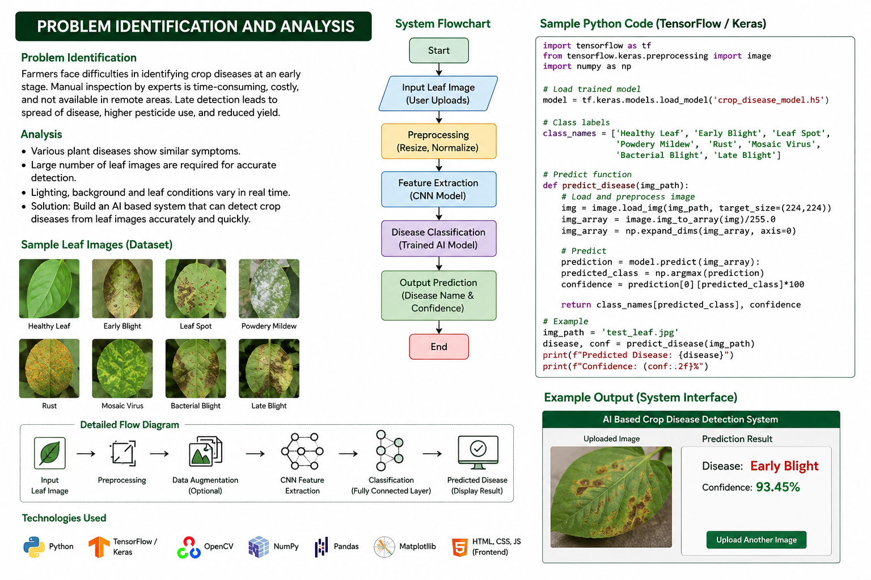

CHAPTER 3

SOLUTION DESIGN AND IMPLEMENTATION
3.1 Development and Design Process

The development of the AI-based crop disease detection system follows a structured development process to ensure accuracy, reliability, and usability. The process begins with requirement analysis, where the functional and non-functional requirements of the system are identified.

The next stage involves dataset collection. Images of healthy and diseased crop leaves are collected and organized according to their respective categories. The images are then preprocessed to improve their quality and provide suitable input for the AI model.

After preprocessing, the dataset is divided into training and testing sets. The AI model is trained using the training dataset so that it can learn the visual characteristics associated with different crop diseases. The trained model is then tested using unseen images.

The final stage involves integrating the trained model into a user interface. The system accepts a crop image as input, processes the image, performs disease classification, and displays the predicted result. Testing and evaluation are performed to measure the accuracy and reliability of the system.

3.2 Tools and Technologies Used

The project employs various hardware and software technologies to support development and implementation.

Hardware Components:
- Computer or laptop for model development.
- Camera or smartphone for crop image acquisition.
- Internet-enabled device for optional cloud-based implementation.

Software Tools:
- Python programming language.
- Jupyter Notebook or Google Colab.
- Image processing libraries.
- Machine learning/deep learning libraries.
- Dataset management tools.
- Web or application development tools.

Technologies:
- Artificial Intelligence.
- Machine Learning/Deep Learning.
- Image Processing.
- Computer Vision.
- Automated Image Classification.
- Optional Cloud or Mobile Application Technologies.

3.3 Solution Overview

The proposed AI-based crop disease detection system is designed to analyze crop leaf images and identify possible diseases. The system architecture consists of an image input module, preprocessing module, AI-based prediction module, and result display module.

The user first captures or uploads an image of a crop leaf. The image is then preprocessed by resizing and normalizing it according to the requirements of the trained model. The processed image is provided as input to the AI model.

The AI model analyzes the visual characteristics of the leaf and predicts the corresponding disease category. The prediction is then displayed to the user through the application interface. The system can optionally provide basic information about the detected disease and recommended preventive measures.

The modular architecture allows future integration with mobile applications, cloud platforms, IoT-based agricultural monitoring systems, and additional crop disease datasets.

3.4 Engineering Standards Applied

Several software engineering and quality practices can be considered during the development of the system:
- ISO/IEC 25010 – Used as a reference for software quality characteristics such as usability, reliability, performance, and maintainability.
- IEEE 29148 – Used as a reference for systematic requirements specification.
- ISO 9001 Quality Management Principles – Used to encourage systematic development, testing, and documentation.
- Software Testing Best Practices – Applied to verify model functionality, application performance, and system reliability.

These practices help improve the quality, maintainability, and reliability of the proposed AI-based system.

3.5 Solution Justification

The use of artificial intelligence provides an effective approach for automated crop disease detection. Unlike manual inspection, an AI-based system can process large numbers of images quickly and provide consistent predictions.

Proper dataset preparation, model training, testing, and performance evaluation improve the reliability of the system. A user-friendly interface also makes the technology more accessible to farmers and other agricultural users.

Overall, the proposed solution provides a practical approach for applying artificial intelligence to agriculture and supports early identification of crop diseases.

CNN Training Source Code:

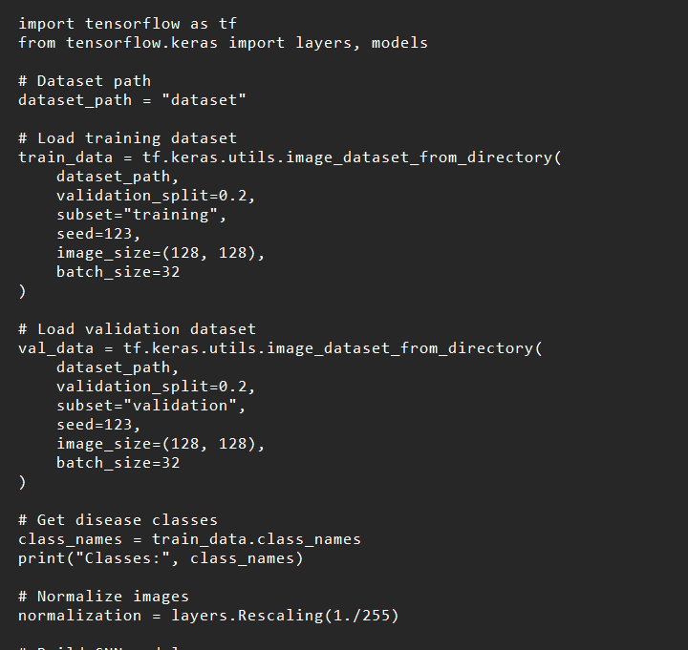

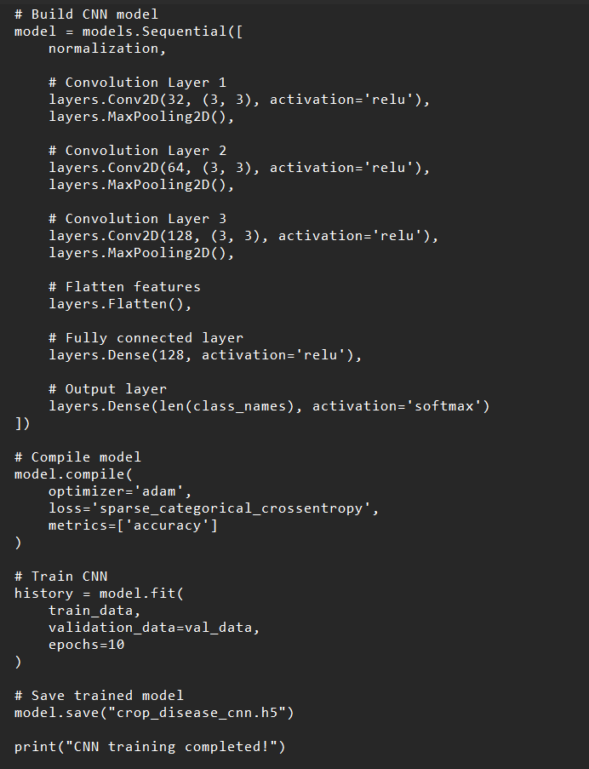

CHAPTER 4

RESULTS AND RECOMMENDATIONS
4.1 Evaluation of Results

The developed AI-based crop disease detection system is evaluated based on its ability to correctly identify healthy and diseased crop images. Testing is conducted using images that were not used during model training.

The performance of the system can be measured using accuracy, precision, recall, F1-score, and prediction time. These measures help determine the effectiveness of the trained AI model.

The system is expected to identify disease patterns from crop leaf images and provide prediction results within a short period. Proper preprocessing and model training can help improve classification performance and reduce incorrect predictions.

Overall, the evaluation determines whether the proposed system meets its objectives of providing automated, fast, and reliable crop disease detection.

4.2 Challenges Encountered

Several challenges may be encountered during the development of the AI-based crop disease detection system. One major challenge is obtaining a sufficiently large and diverse dataset containing high-quality images of different crop diseases.

Another challenge is the variation in image quality caused by lighting conditions, camera quality, background objects, leaf orientation, and disease severity. These variations can affect model performance.

Model training can also require significant computational resources and careful selection of training parameters. Incorrectly labeled images or an imbalanced dataset may result in poor classification performance.

These challenges can be addressed through appropriate preprocessing, dataset balancing, data augmentation, careful model training, and systematic testing.

4.3 Possible Improvements

Although the system can provide effective disease detection, several improvements can be implemented in future versions.

The system can be expanded to support a larger number of crops and disease categories. Disease severity estimation can also be incorporated to determine whether an infection is at an early, moderate, or severe stage.

A mobile application can be developed so that farmers can capture crop images directly from their smartphones. Cloud-based storage and processing can also be integrated for remote access and large-scale agricultural monitoring.

The system may additionally provide disease prevention and treatment information based on the detected disease. Integration with IoT sensors could enable monitoring of environmental conditions such as temperature and humidity.

4.4 Recommendations

Based on the proposed system, further development should focus on collecting diverse and high-quality crop disease datasets. Field testing under real agricultural conditions is recommended to verify system performance outside controlled environments.

Future versions should support multiple crops and disease categories and provide localized recommendations suitable for different agricultural regions.

Integration with mobile applications, IoT devices, and cloud platforms can improve accessibility and scalability. Continuous model updating with new crop disease images can also help maintain prediction performance.

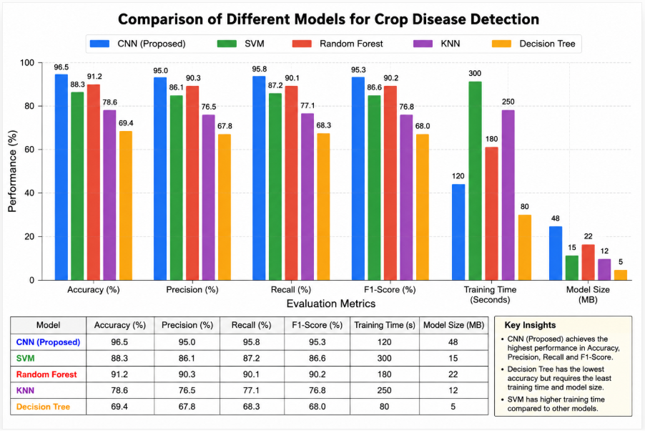

CHAPTER 5

REFLECTION ON LEARNING AND PERSONAL DEVELOPMENT

5.1 Key Learning Outcomes

5.1.1 Academic Knowledge

This capstone project provides an opportunity to apply theoretical knowledge in artificial intelligence, machine learning, image processing, computer vision, and software development.

The project improves understanding of dataset preparation, image preprocessing, AI model training, classification, and performance evaluation. It also demonstrates how academic concepts can be applied to solve real-world agricultural problems.

5.1.2 Technical Skills

The project improves technical skills in Python programming, image processing, AI model development, dataset management, and software implementation.

Experience is gained in preparing datasets, training AI models, evaluating predictions, and integrating the trained model into an application. Testing and debugging also improve practical software development skills.

5.1.3 Problem-Solving and Critical Thinking

Throughout the project, several challenges require analytical thinking and systematic problem-solving. Issues such as incorrect predictions, insufficient training data, image-quality variations, and model performance require careful analysis.

Solving these problems improves the ability to identify causes, evaluate possible solutions, and make informed technical decisions.

5.2 Challenges Encountered and Overcome

5.2.1 Personal and Professional Growth

The project provides practical experience in managing technical challenges, project timelines, and development tasks. Difficulties during dataset preparation, model training, and testing encourage continuous learning and improvement.

Overcoming these challenges strengthens confidence, patience, adaptability, and technical problem-solving abilities.

5.2.2 Collaboration and Communication

Where applicable, collaboration with supervisors and team members contributes to the successful development of the project. Discussions and feedback help improve the AI model, system design, documentation, and overall project quality.

The project also improves the ability to communicate technical concepts clearly and work effectively as part of a team.

5.3 Application of Engineering Standards

The application of software engineering principles and quality practices helps improve the reliability and maintainability of the AI-based crop disease detection system.

Systematic requirements analysis, structured development, testing, documentation, and performance evaluation help reduce errors and improve the overall quality of the project.

5.4 Insights into the Industry

This project provides valuable insight into the practical application of artificial intelligence in the agricultural industry. It demonstrates the importance of balancing accuracy, computational requirements, usability, cost, and real-world conditions when developing AI solutions.

The project also highlights the growing role of AI, computer vision, and automation in smart agriculture and precision farming.

5.5 Conclusion of Personal Development

In conclusion, the capstone project strengthens technical knowledge and practical skills in artificial intelligence and agricultural technology. It improves problem-solving, programming, teamwork, communication, testing, and system development abilities.

Overall, the project provides valuable practical experience and prepares the student for future professional opportunities in artificial intelligence, machine learning, software development, and smart agriculture.

CHAPTER 6
CONCLUSION
This capstone project addressed the ongoing challenge of inaccurate and time-consuming crop disease identification in agricultural environments. Traditional disease detection methods often depend on manual observation and expert knowledge, which can result in delayed identification and increased crop losses. To address this problem, an AI-based crop disease detection system was designed and implemented using artificial intelligence, image processing, and image classification techniques.
The developed system successfully achieves its objectives by analyzing crop leaf images and identifying whether the plant is healthy or affected by a particular disease. Through appropriate dataset preparation, image preprocessing, AI model training, and structured software development, the system provides fast and consistent disease prediction. The integration of automated image analysis significantly reduces the time required for disease identification and helps farmers take timely preventive measures.
The value of this project lies in its practical contribution to modern and smart agriculture. It demonstrates how artificial intelligence and computer vision can be applied to solve real-world agricultural problems using accessible technologies. Academically, the project strengthens the application of theoretical knowledge in artificial intelligence, machine learning, image processing, and software development. Socially, it can contribute to improved crop productivity, reduced crop losses, and more efficient agricultural practices.
In conclusion, the AI-based crop disease detection system represents an effective and scalable solution to modern agricultural challenges. The project highlights the importance of intelligent automation, accurate image analysis, and user-friendly system design in developing smart farming solutions. It also provides a strong foundation for future enhancements such as mobile-based disease detection, disease severity estimation, IoT integration, cloud-based monitoring, and automated treatment recommendations.

CHAPTER 7
REFERENCES
[1] A. Abade, P. A. Ferreira, and F. de Barros Vidal, “Plant diseases recognition on images using convolutional neural networks: A systematic review,” Computers and Electronics in Agriculture, vol. 185, Art. no. 106125, 2021.
[2] R. Gao, R. Wang, L. Feng, Q. Li, and H. Wu, “Dual-branch, efficient, channel attention-based crop disease identification,” Computers and Electronics in Agriculture, vol. 190, Art. no. 106410, 2021.
[3] S. Kendler, R. Aharoni, S. Young, H. Sela, T. Kis-Papo, T. Fahima, and B. Fishbain, “Detection of crop diseases using enhanced variability imagery data and convolutional neural networks,” Computers and Electronics in Agriculture, vol. 193, Art. no. 106732, 2022.
[4] P. Li, R. Jing, and X. Shi, “Apple disease recognition based on convolutional neural networks with modified Softmax,” Frontiers in Plant Science, vol. 13, Art. no. 820146, 2022.
[5] M. Jung, J. S. Song, A.-Y. Shin, B. Choi, S. Go, S.-Y. Kwon, J. Park, S. G. Park, and Y.-M. Kim, “Construction of deep learning-based disease detection model in plants,” Scientific Reports, vol. 13, Art. no. 7331, 2023.
[6] “Crop disease diagnosis and prediction using two-stream hybrid convolutional neural networks,” Crop Protection, Art. no. 106867, 2024.
[7] C. Pal, S. Karmakar, I. Mukherjee, and P. P. Chakrabarti, “A lightweight and explainable CNN model for empowering plant disease diagnosis,” Scientific Reports, vol. 15, Art. no. 30720, 2025.
[8] P. Pai, S. Amutha, S. Patil, T. Shobha, M. Basthikodi, B. M. A. Shafeeq, et al., “Deep learning-based automatic diagnosis of rice leaf diseases using ensemble CNN models,” Scientific Reports, vol. 15, Art. no. 27690, 2025.
[9] K. Sahu, S. Tiwari, M. K. Singh, J. Pahareeya, H. K. Shakya, G. K. Kumar, et al., “Plant disease detection using a hybrid dilated CNN with attention mechanisms and optimized Mask R-CNN segmentation,” Scientific Reports, vol. 15, Art. no. 42008, 2025.
[10] D. Devarajan, R. Allafi, M. Obayya, et al., “AI based real time disease diagnosis in plants using deep learning driven CNNs,” Scientific Reports, vol. 16, Art. no. 4587, 2026.
[11] B. Muthu and C. Cherubini, “A novel approach for crop disease detection using transfer-learning-based deep convolutional neural networks,” Neural Computing and Applications, vol. 38, Art. no. 500, 2026.
[12] A. Ray, T. K. Murugan, L. Govindaraj, et al., “Explainable CNN framework for accurate crop disease detection using plant leaf images,” Scientific Reports, 2026.

